Digital Humanities for Korean Studies Learning Camp
June 2–6, 2025

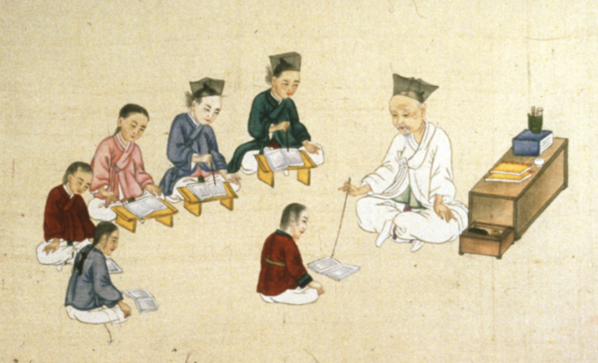

Is “Premodern” in Korean Studies Now Anything Before 1988?
New Web-based Language Learning Resources
for the Ambitious Student
Prof. Ross King, University of British Columbia

In this series of sessions, Professor King will showcase the resources he has developed for ‘ambitious’ students of Korean language and literature working at the upper levels of undergraduate specializations in Korean Studies and/or at the graduate level. Those resources are: Introduction to Hancha: Sinographs and Sino-Korean Vocabulary I & II, Readings in Middle Korean, Materials for teaching hanmun in and through Korean, using Korean texts, Modern Korean Short Fiction. The idea is that students must be not only ‘advanced’ but ‘ambitious’ if they wish to study materials printed in Korea before 1988, for the obvious reason that one needs hancha to read newspapers printed before then in South Korea, and this in turn serves as a segue to the problem of teaching resources for premodern materials: Middle Korean and hanmun. Professor King will then return to the conundrum of teaching materials for advanced learners wanting to read modern fiction (including works from the colonial period), which segues to James Scarth Gale’s work at the Christian Literature Society and his resistance to the modern Korean literary idiom just being thrashed out then.

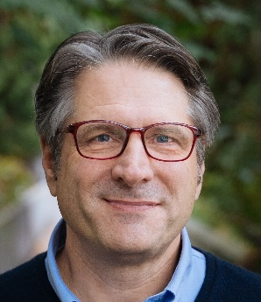 | Ross King earned his BA in Linguistics and Political Science from Yale College and his MA and PhD from Harvard in Linguistics. Currently he serves as Professor of Korean in the Department of Asian Studies at the University of British Columbia in Vancouver, Canada. His research focuses on the cultural and social history of language, writing, and literary culture in Korea and in the Sinographic Cosmopolis more broadly, with a particular interest in comparative histories of vernacularization. He serves as Editor-in-Chief of Sungkyun Journal of East Asian Studies, as Managing Editor of the Korean Studies Library (Brill), and as co-editor of the series “Language, Writing and Literary Culture in the Sinographic Cosmopolis” (also Brill). He is the author of “I Thank Korea for her Books:” James Scarth Gale, Korean Literature in hanmun, and Allo-metropolitan Missionary Orientalism (forthcoming, University of Toronto Press), and the co-author of Elementary Korean, Continuing Korean, and Advanced Korean (all from Tuttle Publishing). He is also the founding Dean of the Korean Language Village at Concordia Language Villages in northern Minnesota and co-founder and co-chair of the Inter-University Center for Korean Language Studies at SKKU (https://iuc.skku.edu/iuc/introduciton.do).

