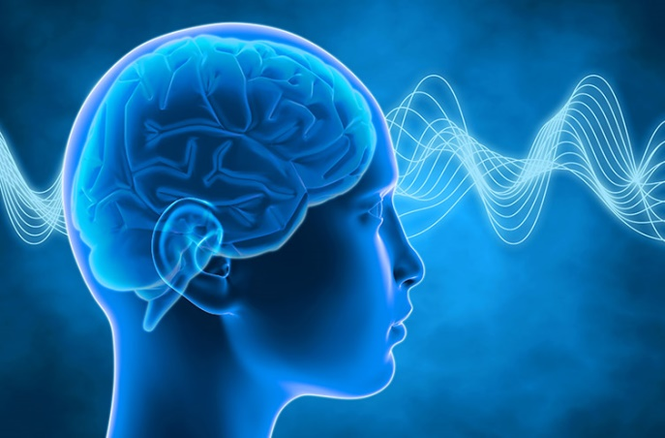

DIALOGUE BETWEEN NATURAL SCIENCES & RELIGION

Welcome believers as well as non-believers to this new domain, which demonstrates its need for today against all shades of fundamentalisms.
How? By keeping alive Isaiah’s call: “Come now, and let us reason together! “

Some themes:
- Intro to Dialogue Science-Religion – 3 Big Bangs
- Neuro-Sciences and Religion
- Open versus Closed Systems
- Non-Christian Religions and Science
- New Phylum of Christianity with Evolution already inserted

Seminars are for religious as well as non-religious students to enrich their views on these two domains, Natural Sciences and Religion.
Code: KST/DNSR (Instructor: ThLic. Ing. František (Frank) Mikeš, Ph.D.)
Summer Semester: 11.2.–14.5.2019
First Class: 13.2. and also 20.2.2019, 17:20-18:55, then classes will be fixed.
Building and Room: Univerzitní 22, Room U11
Form of Ending: Combined
Credits: 4

