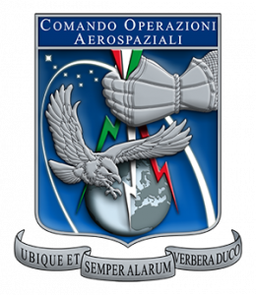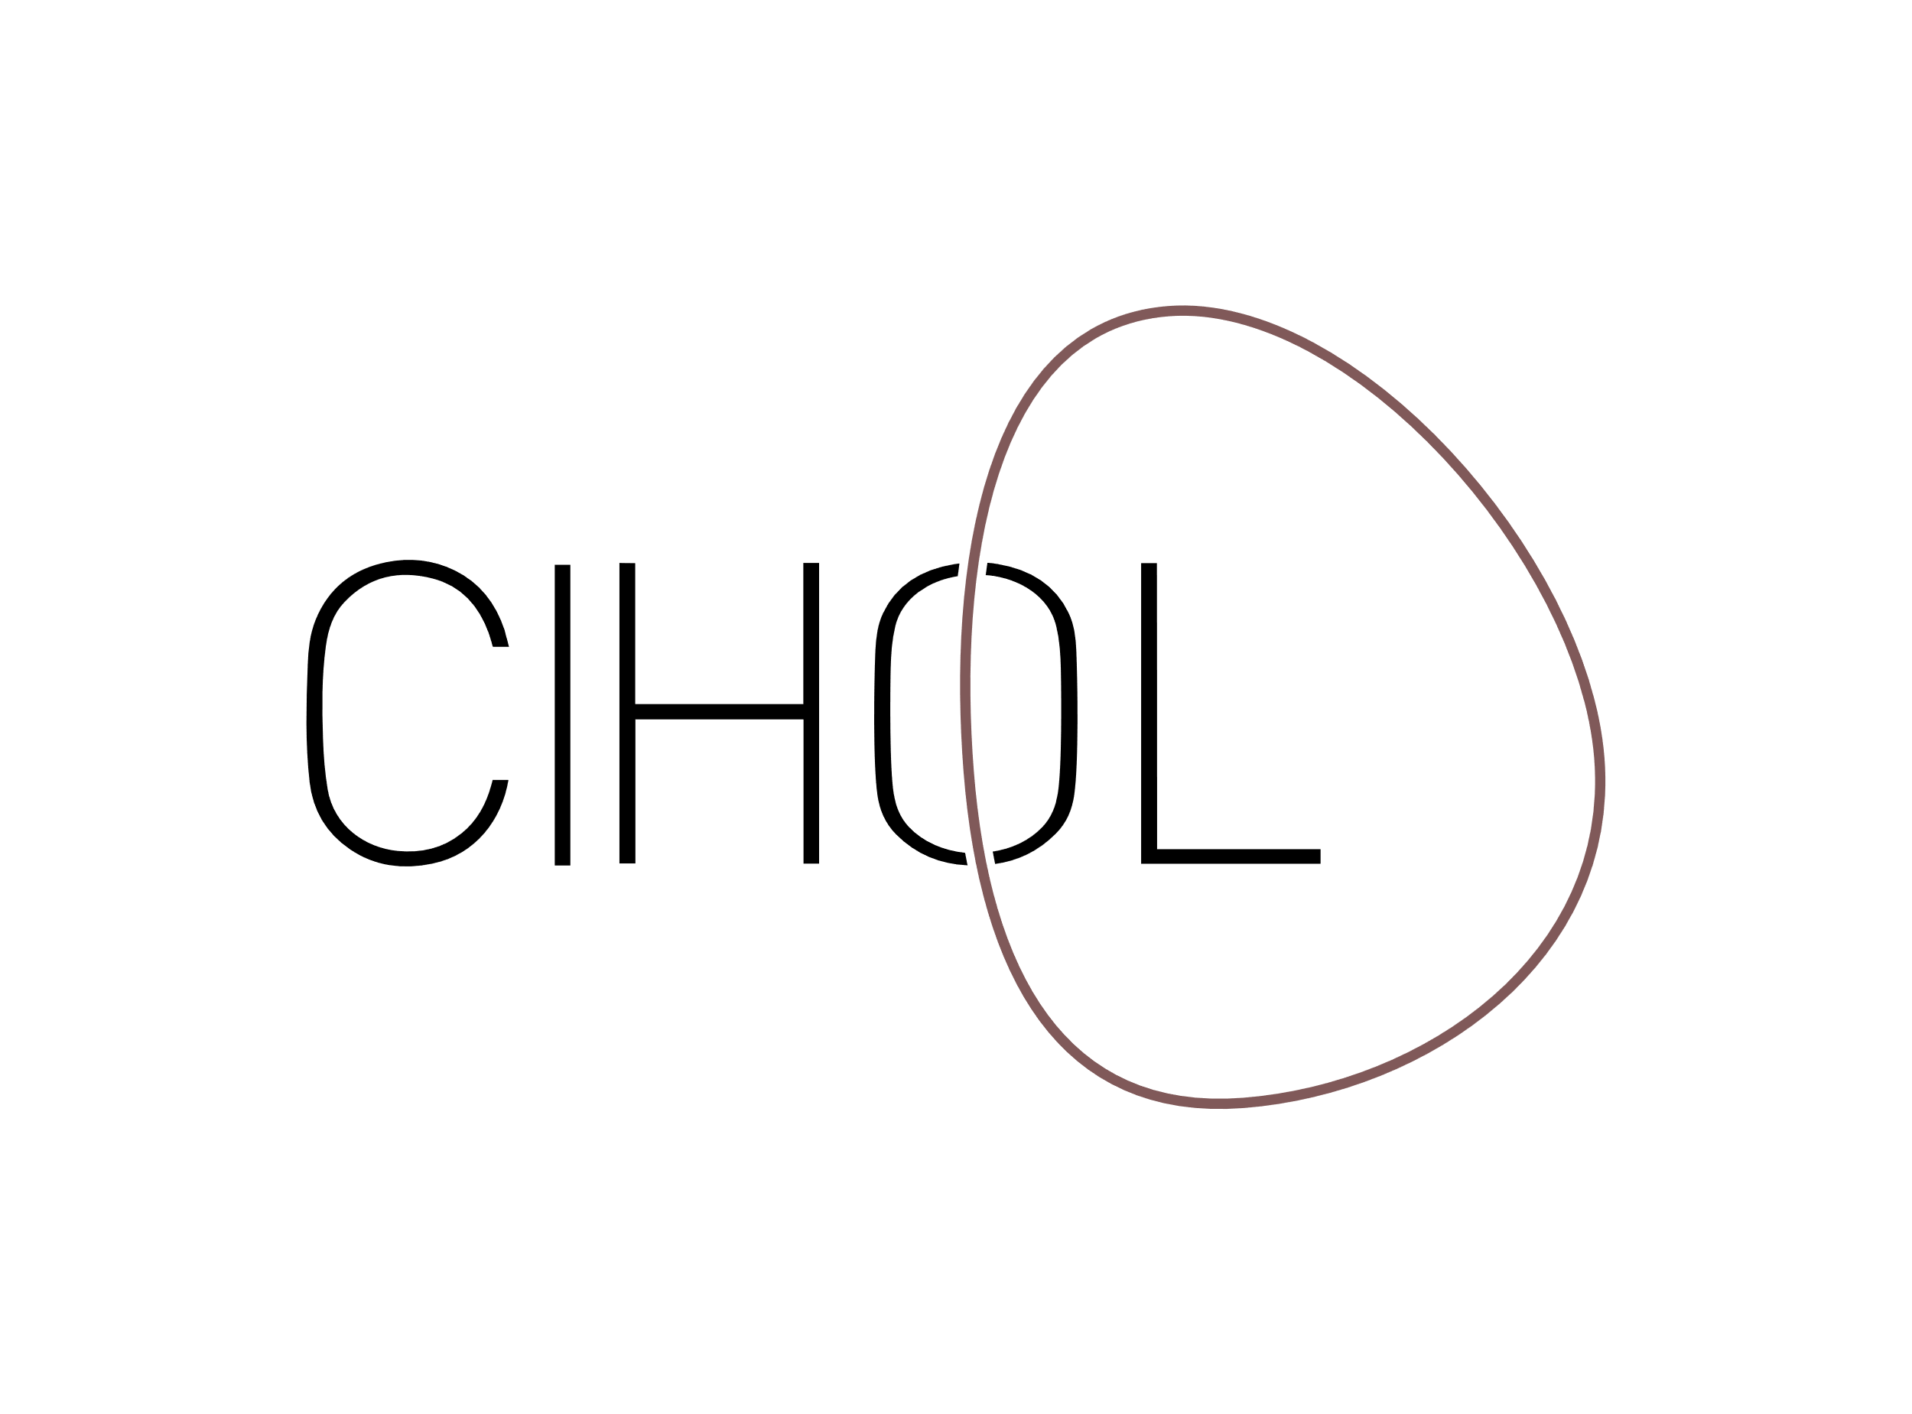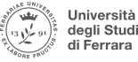

[**The Centre for International Humanitarian and Operational Law of the Faculty of Law, Palacky University Olomouc**](https://www.pf.upol.cz/cihol/) **and the** [**University of Ferrara, Dipartimento Di Giurisprudenza**](https://giuri.unife.it/en?set_language=en)**, have the pleasure to invite you to the international workshop focusing on various aspects of international law of armed conflict.**

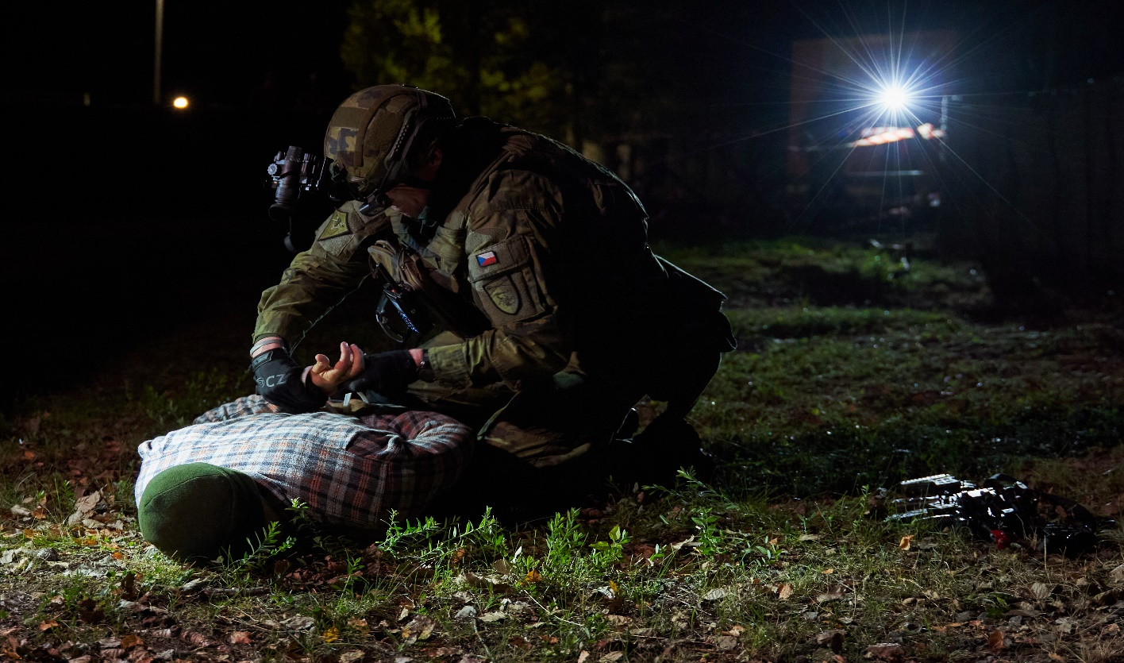

**WORKSHOP**

**LAW OF ARMED CONFLICT**

The workshop will take place on **23 of May 2024 from 9:30 to 12:30**. The event organised in hybrid form will be attended by academics, students and military personnel both from Italy and Czech Republic.

**Discussed topics will cover:**

* Identification and classification of armed conflicts (law-enforcement 🡪 NIAC 🡪 IAC)
* Law enforcement in occupied territories
* Critical civilian infrastructure as target of military operations (with examples from Ukraine, such as energy infrastructure or oil installations, or Gaza)
* Distinction between mercenaries, foreign fighters and private military companies
* Protection of military installations on national territory

**We have the honour to introduce the following speakers:**

* Prof Martha Bradley, University of Johannesburg, South Africa
* Dr Petr Stejskal, Palacky University Olomouc (Centre for International Humanitarian and Operational Law)
* Dr Marko Svicevic, Palacky University of Olomouc (Centre for International Humanitarian and Operational Law)
* Prof Alessandra Annoni, Ass Prof. of international law at the University of Ferrara
* Marco Giulio Tasso (Commando RSSG, Poggio Renatico)
* Dr Diego Mauri (University of Palermo)

The workshop will take place in hybrid format, being streamed both from Ferrara and Olomouc. You are welcome to join us online through the following link: [https://meet.google.com/shf-nppw-mzo](HTTPS://MEET.GOOGLE.COM/SHF-NPPW-MZO)

Contact person: Dr Petr Stejskal, [petr.stejskal@upol.cz](mailto:petr.stejskal@upol.cz)