Memorandum of Understanding
Sponsorship Agreement

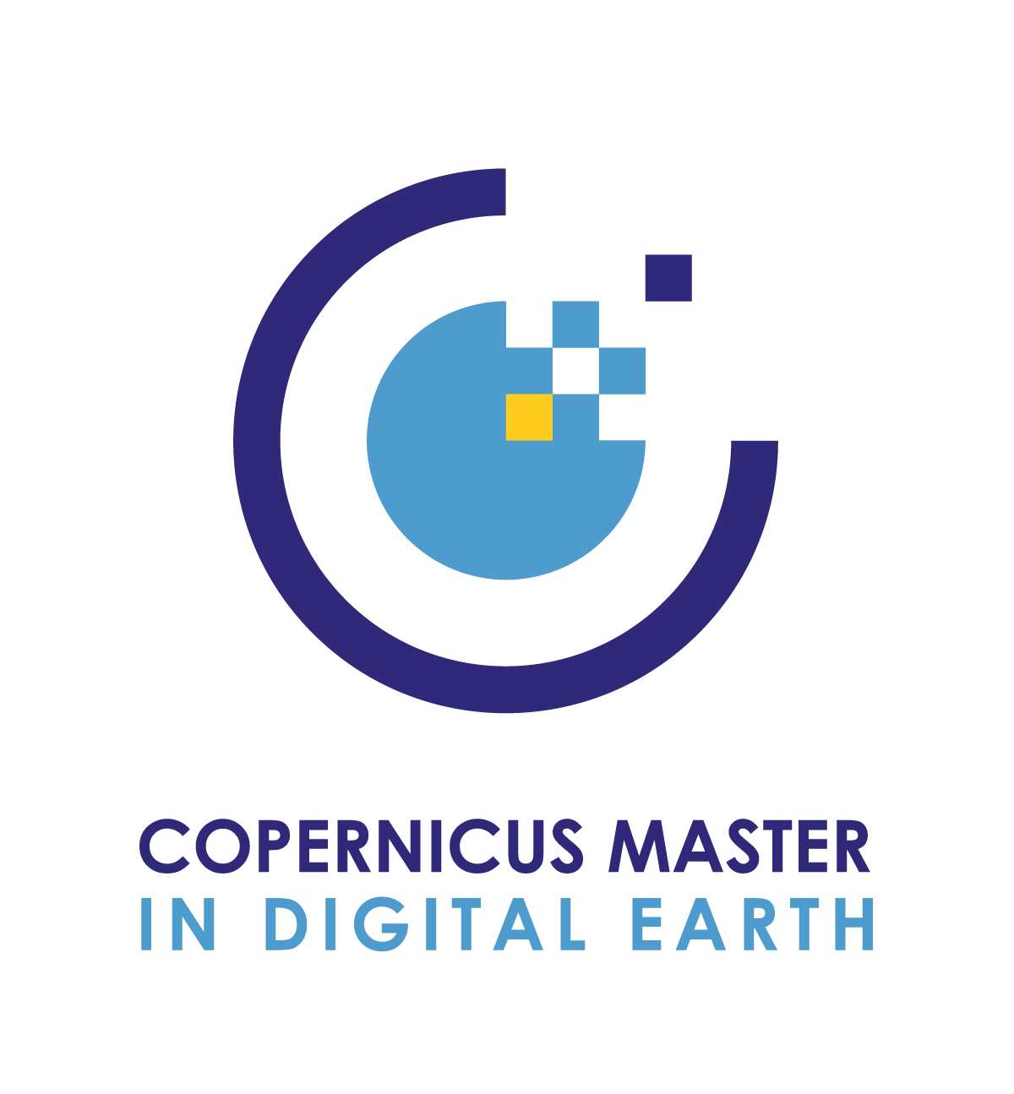

The institutions signing this Memorandum of Understanding agree on following points of accord to establish a working relationship and student sponsorship offers.

contents
1. COPERNICUS MASTER IN DIGITAL EARTH 2
2. SPONSORSHIP VALUATION 3
3. Sponsorship packages 4
4. SIGNATURES 5

COPERNICUS MASTER IN DIGITAL EARTH
Copernicus Master in Digital Earth (CDE) is a two-year full-time integrated Erasmus Mundus Joint Master (EMJM), funded under the Erasmus+ programme, co-funded by the European Union. The English language Master of Science (MSc) is jointly offered to outstanding candidates as double degree.
In short, CDE is unique & international, with a focus on Copernicus and Digital Earth studies at European’s top universities. As part of the MSc, students must complete short intensive programmes, e.g., schools and a compulsory work placements, internship related to the programme. CDE faculty offers comprehensive scientific support in a team of committed supervisors and they are promoting research-driven education. All MSc theses are research based and co-supervised by academic faculty from at least two different partner universities.
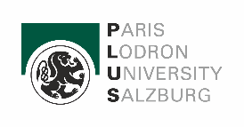 | At Paris-Lodron University, Department of Geoinformatics (Z_GIS), Salzburg, Austria students gain profound EO*GI application-oriented expertise based on relevant theories and methods. The two specialization tracks offer a unique combination of courses in the second academic year.
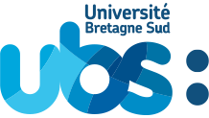 | At University of South Brittany, Computer Science Department, OBELIX team of IRISA (Institute for Research in Computer Science and Random Systems), Vannes, France students specialize in Computer Science/Data Science including computer vision, machine learning and big data with a focus on data analytics for Earth Observation.
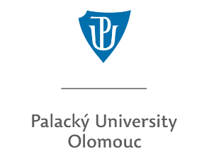 | At Palacky University Olomouc, Faculty of Science, Department of Geoinformatics, Olomouc, Czech Republic students specialize in Geovisualisation, Geocommunication and application development, including Cartography and design in Geovisualisation, Web and cognitive Cartography, 3D Visualisation, and advanced visualisation methods.

SPONSORSHIP VALUATION
A student sponsorship allows a sponsor to attract and develop talented students, either possibly attracting them as employees later or jointly translating your research interests and needs into practice during e.g., work placements, internships or Master’s Thesis research. It will display your social responsibility and services, reinforce your image and create further visibility and awareness of your activities.

CDE determines the value of your sponsorship inventory and aims to define your sponsorship valuation formula with a list of potential benefits:
- Participation in CDE project meetings, which allows to interact with peers from academia, alumni and associated partners and exchange first-hand information about EO*GI education trends.
- Participation in workshops or summer schools.
- First-hand access to Master’s Theses research and outcomes (publications), student’s internship (work placement) reports.
- Initiation of research and education projects at international level with consortium and alumni.
- Invitation as CDE guest lecturer.
- Networking with consortium members, students and alumni.

The SPONSOR, [name], fully supports this MSc study programme and agrees on following items:
[please see 3. SPONSORSHIP PACKAGES]
- 1 Platin sponsorship
- 2 Gold student sponsorships
- 1 Silver student sponsorship
- 1 Bronze student sponsorship

- Offer internship/work placements
- Support the dissemination and sustainability of the study programme
- Provide knowledge and skills transfer (serve as external expert or board member)
- Contribute to the joint development of a sustainability plan which secures operation beyond EU funding
- [Additional elements/changes may be included in order to tailor the agreement]

Student selection is undertaken by the CDE Selection Committee based on the academic qualifications and merits shown in the application documents. The CDE programme provides a total of 30 study places, however, the number of eligible (short-listed) applicants, seeking a study place based on an Erasmus+ EMJM scholarship exceeds the number of students that can be accepted per cohort. A sponsor may serve as a member of the Selection Committee.

Sponsorship packages
As detailed hereafter, several packages have been tailored to offer a variety of sponsoring opportunities from industry or other private actors.

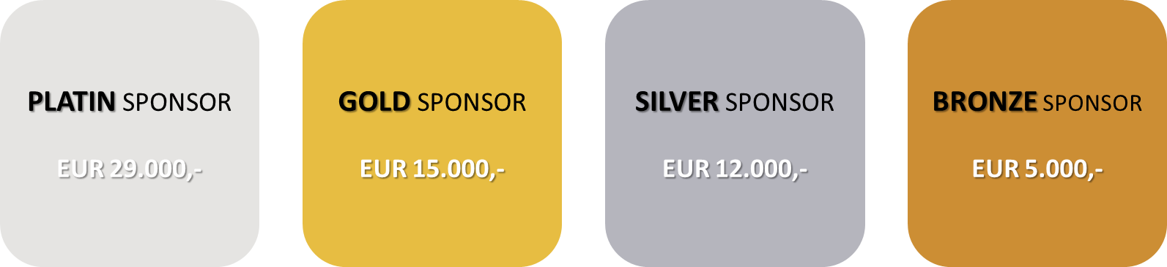

The Platin sponsorship amounts to EUR 29.000,- and covers estimated living and travel costs for two years. The Gold sponsorship of EUR 15.000.- is a contribution to one year living and travel costs. The Silver sponsorship amounts to EUR 12.000,- and supports one year of living costs. The Bronze sponsorship, EUR 5.000,- is a contribution to travel costs for two years.
https://master-cde.eu/costs-funds/sponsorship

SIGNATURES
The undersigned, confirm on behalf of their institutions their collaboration in and endorsement of the above-mentioned Master of Science study programme.

Nominated Contact Person | Joint-Coordinator  Copernicus Master in Digital Earth – CDE
Assoc-Prof. Dr. Stefan Lang
Paris-Lodron University Salzburg
Department of Geoinformatics – Z_GIS
Schillerstrasse 30, 5020 Salzburg, Austria
Place, date | Place, date
Signature | Signature

