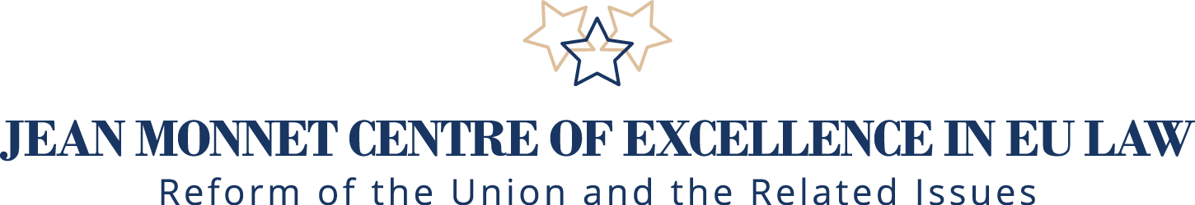

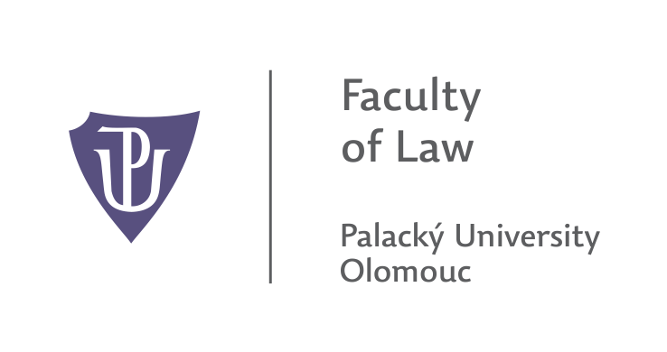

**Jean Monnet International Scientific Workshop**

**23. 11. – 24. 11. 2017**

**New Forms and Methods of Teaching and Education in European Integration Subjects –**

**A Comparative view**

**Venue: Faculty of Law, Palacký University,**

**Olomouc, Tř. 17. Listopadu 8, 779 00**

**23. 11. (Thursday) First day of the Workshop**

**Venue:** Faculty of Law, **Building A- Rotunda**

**Registration:** **10:00 – 10:00**; **Opening: 11:00**

**Plenary session**

**Chair:** Assoc. Prof. et. Assoc. prof. JUDr. **Naděžda Šišková**, Ph.D, Head of Jean Monnet Centre of Excellence in EU Law, Faculty of Law, Palacky University, President of the Czech Association for European Studies – Czech ECSA

**Welcome address:**

* **11:00 – 11: 10**

Assoc. Prof. et. Assoc. prof. JUDr. **Naděžda Šišková**, Ph.D, Head of Jean Monnet Centre of Excellence in EU Law, Faculty of Law, Palacky University, President of the Czech Association for European Studies – Czech ECSA**11:20 – 11: 30**

* **11: 20 – 11: 30**

JUDr. **Zdenka Papoušková**, Ph.D., Dean at the Faculty of Law, Palacky University in Olomouc

**Keynote speeches:**

* **11:30 – 12:00**

Doc. Ing. **Pavel Svoboda,** Ph.D.**,** Chair of the **Committee** on Legal Affairs of European Parliament

***“Future of EU institutions and its reflection in EU studies***

* **12:00 – 12: 30**

Prof. Dr. Dr. h.c. mult. **Peter-Christian Müller-Graff** (Director of Institute for European Law, University of Heidelberg, Jean Monnet Chairholder, President of German ECSA) (to be confirmed)

***“Education in EU Studies”***

* **12:30 – 12:50: *Discussion***
* **12:50 – 13:40: *Lunch***

**Section 1. Chair:** Prof. **Tibor Palankai**, Ph.D., [Corvinus University of Budapest](https://doktori.hu/index.php?menuid=190&lang=EN&i_ID=2),

Corresponding Member of Hungarian Academy of Sciences

* **13:40 – 14:00**

Mag. **Roman Puff**, Senior Scientist, Paris Lodron University Salzburg, Salzburg Centre for EU Studies – SCEUS

***“Challenges in EU Studies: Experiences from Salzburg”***

* **14: 00 – 14: 20**

Prof. **Viktor I. Muraviov** (Head of Chair of Comparative and European Law at Taras Schevchenko Natinal University in Kiev)

***“The Development of teaching on EU Law in Ukraine”***

* **14:20 – 14:40**

Assoc. Prof. JUDr. **Filip Křepelka**, Head of the Department of International and European Law, Faculty of Law, Masaryk University in Brno

“***Education in EU Law : case of Czech administrative judiciary”***

* **14:40 – 15:00**

Assoc. Prof. JUDr**. Blanka Vítová**, Ph.D., LL.M., Vice-Dean at Faculty of Law, Palacky University in Olomouc, Member of Jean Monnet Centre of Excellence in EU Law

***“Informal methods of EU consumer law education (street-law)”***

* **15: 00 – 15:20:** ***Discussion***
* **15:20 – 15:40:** ***Coffee break***

**Section 2. Chair:** Assoc. Prof. JUDr**. Blanka Vítová**, Ph.D., LL.M., Vice-Dean at

Faculty of Law, Palacky University in Olomouc, Member of Jean Monnet

Centre of Excellence in EU Law

* **16:00 – 16:20**

Assoc. Prof. et. Assoc. prof. JUDr. **Naděžda Šišková**, Ph.D. (Head of Jean Monnet Centre of Excellence in EU Law, Faculty of Law, Palacky University, President of the Czech Association for European Studies – Czech ECSA)

***“Jean Monnet Programme in the Czech Republic and its importance for introduction of the subjects of European integration”***

* **16:20 – 16: 40**

JUDr. **David Sehnálek**, Ph.D., Lecturer in European Union law, Faculty of Law, Masaryk University)

***“Teaching of Legal Skills – the Perspective of EU Law”***

* **16:40 – 17:00**

Assoc. Prof. JUDr. PhDr. **Lucia Mokrá**, Dean, Faculty of Social and Economic Sciences, Comenius University in Bratislava

***“Teaching EU law and policies in non-legal studies, challenges and opportunities”***

* **17:00 – 17:20: *Discussion***
* **17:30: *Glass of wine***

**24. 11. (Friday) Second day of the Workshop**

**Venue:** Faculty of Law, **Building A- auditorium 3**

**Registration: 8:30 – 9:00**

**Section 3. Chair:** JUDr. **Pavel Bureš,** Ph.D., Department of International and European

Law, Faculty of Law, Palacky University in Olomouc

* **9:00 – 9:20**

JUDr. **Maxim Tomoszek**, Ph.D., Vice-dean at the Faculty of Law, Palacky University

in Olomouc

***“Clinical Legal Education in the Area of European Law ”***

* **9:20 – 9:40**

Mgr. **Zuzana Vikarská**, Lecturer, Faculty of Law Masaryk University in Brno, Law

Clerk of Czech Constitutional court

***“Learning REU Law through participation in moot court competitions”***

* **9:40 – 10:00**

JUDr. **Petr Michal**, Ph.D,. Member of Jean Monnet Centre of Excellence in EU Law, Faculty of Law, Palacky University in Olomouc

***“Connection of EU courses with practice and its reflection in education”***

* **10: 00 – 10:20: *Discussion***
* **10:20 – 10: 40: *Coffee Break***

**Section 4. Cahir:** JUDr. **Petr Michal**, Ph.D,. Member of Jean Monnet Centre of

Excellence in EU Law, Faculty of Law, Palacky University in Olomouc

* **10: 40 – 11:00**

Mgr. **Petra Meštanková**, Ph.D., Faculty of Law, Palacky University in Olomouc

***“Interdisciplinary approach to teaching European studies at the example of European studies focusing on European Law”***

* **11:00 – 11:20**

JUDr. **Pavel Bureš,** Ph.D., Department of International and European Law,

Faculty of Law, Palacky University in Olomouc

***“Erasmus exchange programme – facing new challenges ( at the Palacky University, Faculty of Law)”***

* **11:20 – 11:40**

Ba.**Ian Bell**, Lecturer, Department of Languages, Faculty of Law, Palacky University

***“Teaching English for specific purposes and its importance for education in EU Law”***

* **11: 40 – 12:00: Discussion**
* **12:30**:  ***Ending of the Workshop***

**Scientific and Organization Committee**

**Head of the Committee and a scientific quaranteee:**

Assoc. Prof. et. Assoc. Prof. JUDr. **Naděžda Šišková**, Ph.D., Head of Jean Monnet Centre of Excellence in EU Law, Faculty of Law, Palacky University in Olomouc, President of the Czech association for European studies

**Members of the Committee:**

Assoc. Prof. JUDr. **Blanka Vítová**, Ph.D., LL.M., Vice-Dean at Faculty of Law, Palacky University in Olomouc, Member of Jean Monnet Centre of Excellence in EU Law

JUDr. **Ondrej Hamulák**, Ph.D., Member of Jean Monnet Centre of Excellence in EU Law, Faculty of Law, Palacky University in Olomouc, Member of Jean Monnet Centre of Excellence in EU Law

JUDr. **Zdenka Papoušková**, Ph.D., Dean at the Faculty of Law, Palacky University in Olomouc

JUDr. **Michal Petr**, Ph.D., Member of Jean Monnet Centre of Excellence in EU Law, Faculty of Law, Palacky University in Olomouc,